Nama : Dandi Hendika

NPM : 222310005

Kelas : TI-22-PA1

OUTPUT TUGAS 3 – 6

3.1 Login screen

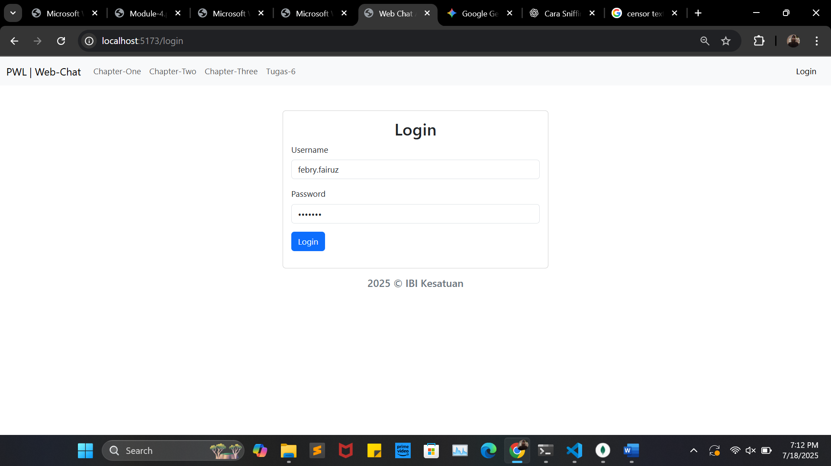

3.2 Route

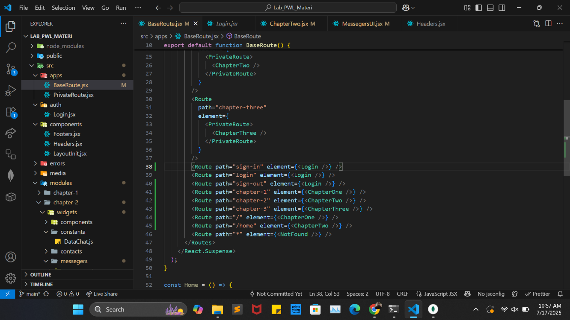

3.3 Fitur search

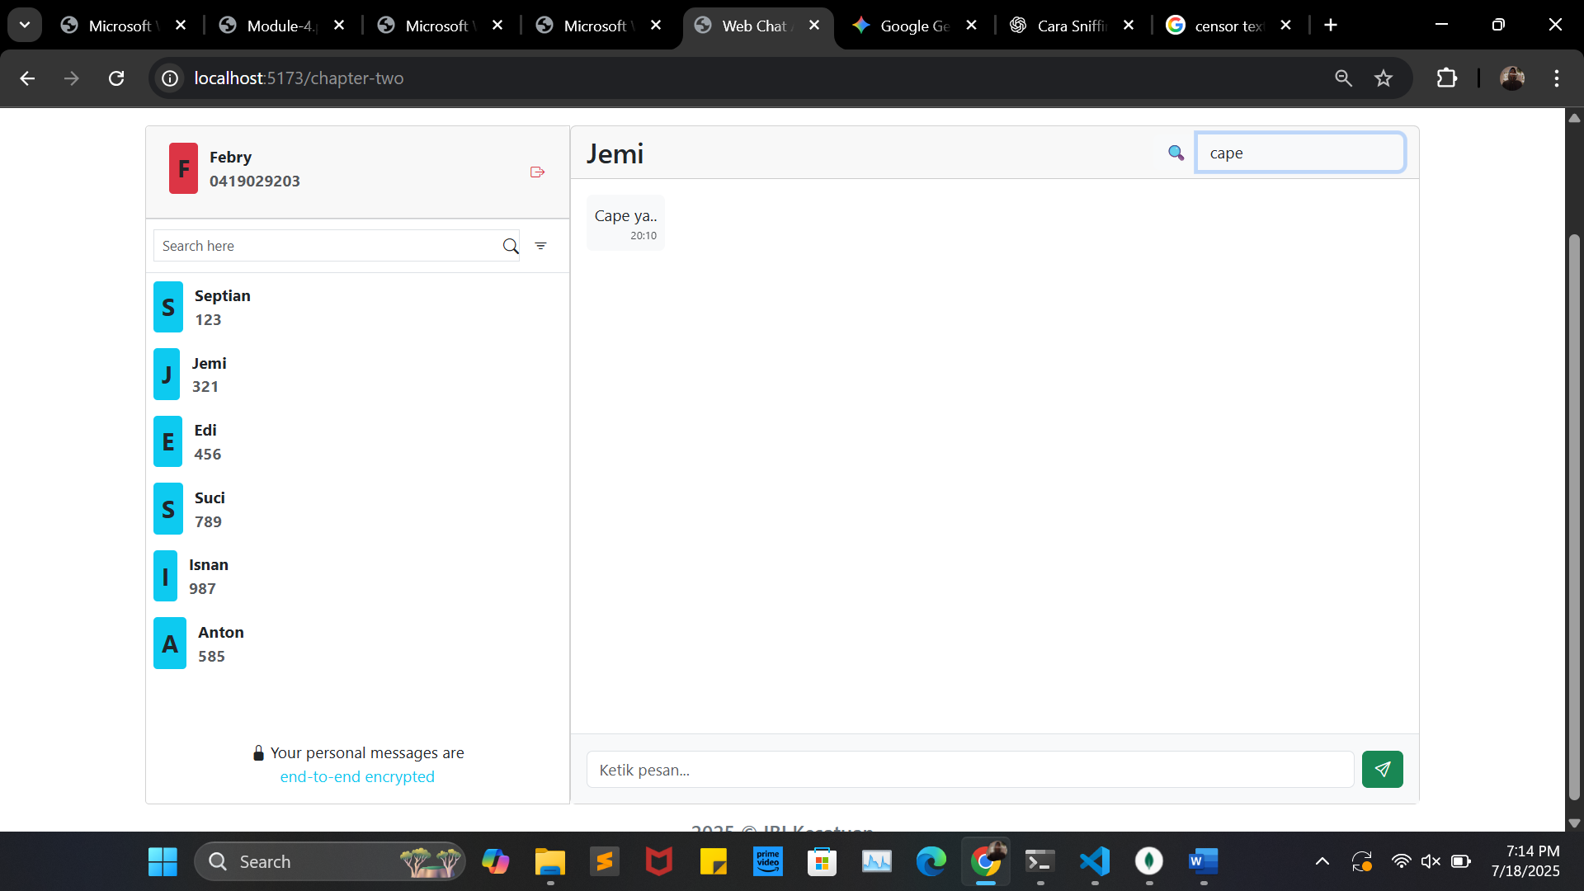

4.1 Tambah update dan delete

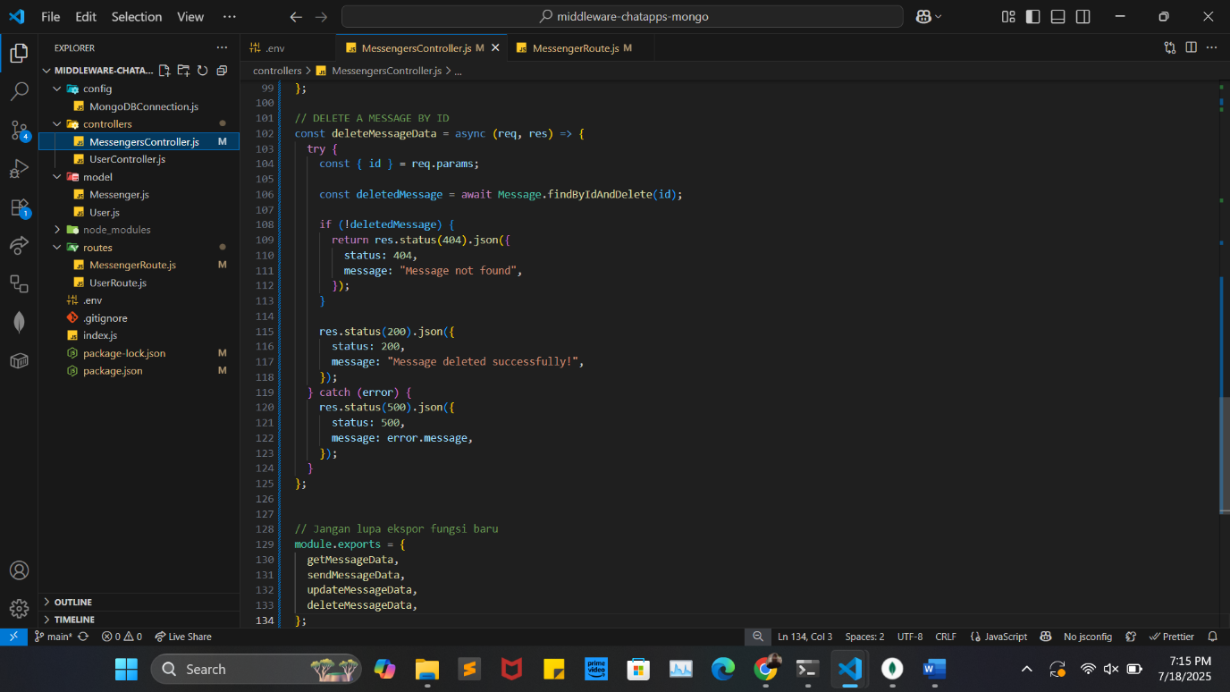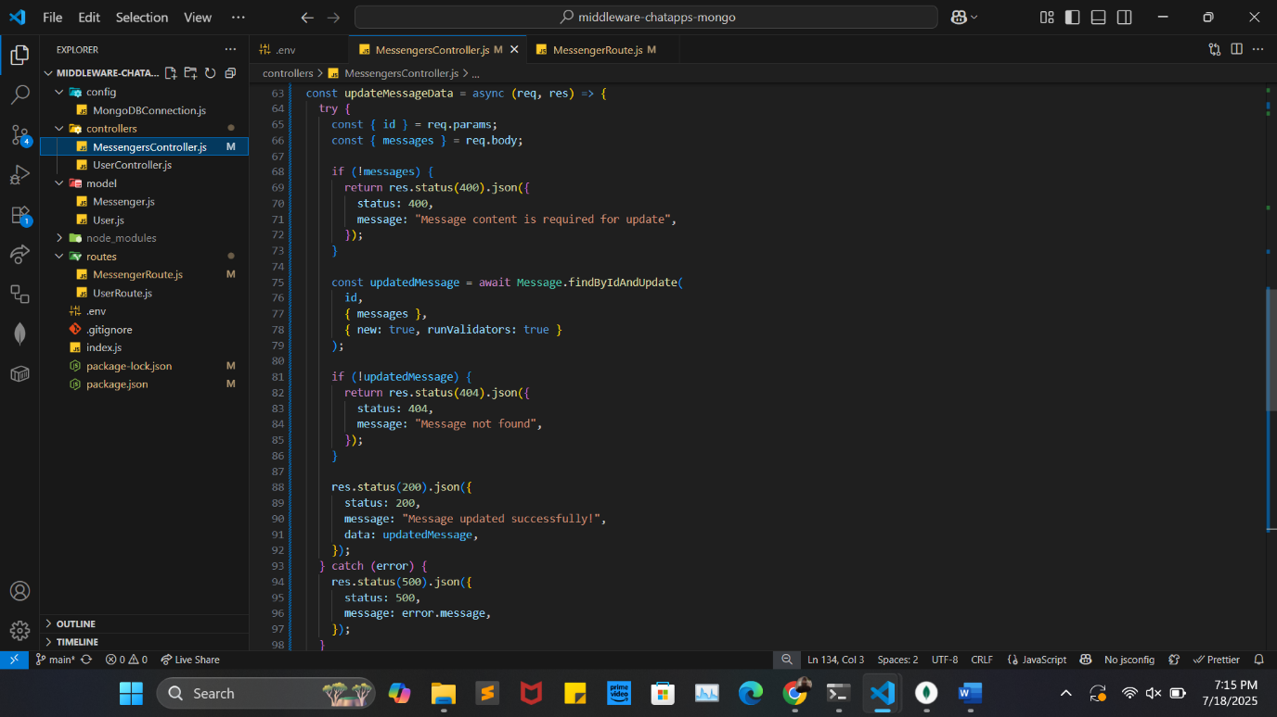

5.1 Edit chat

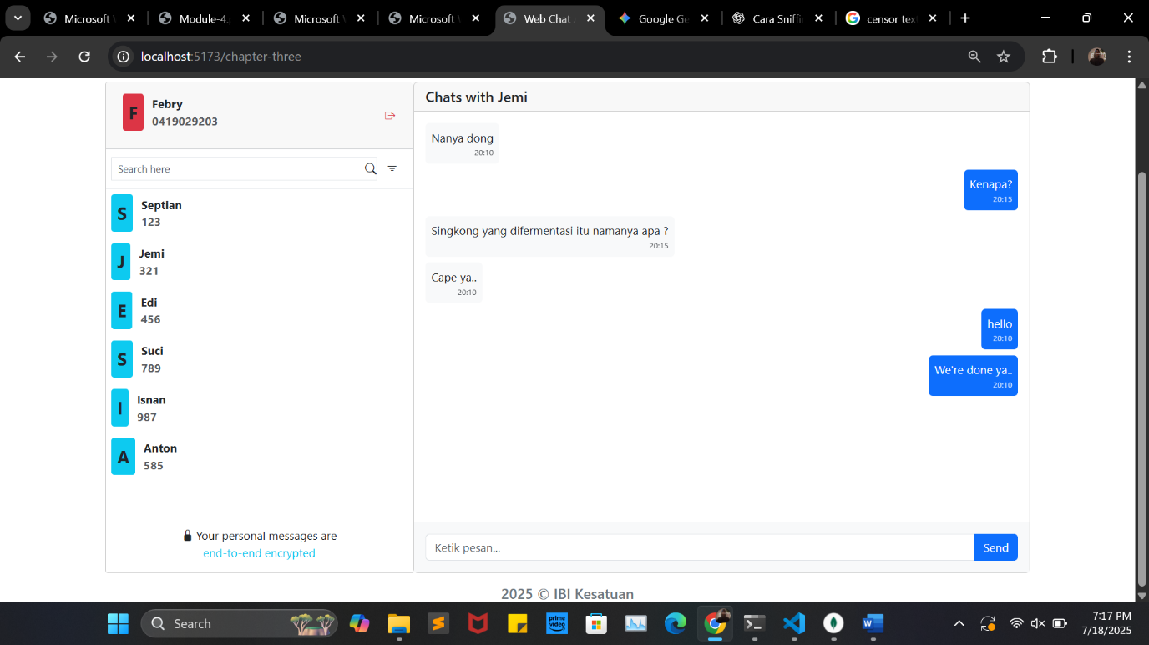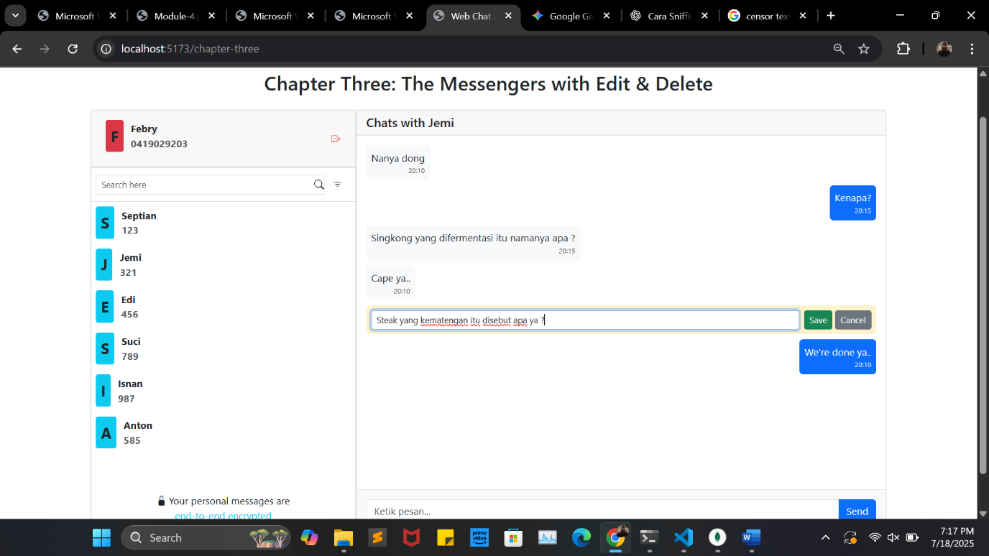

5.2 Delete

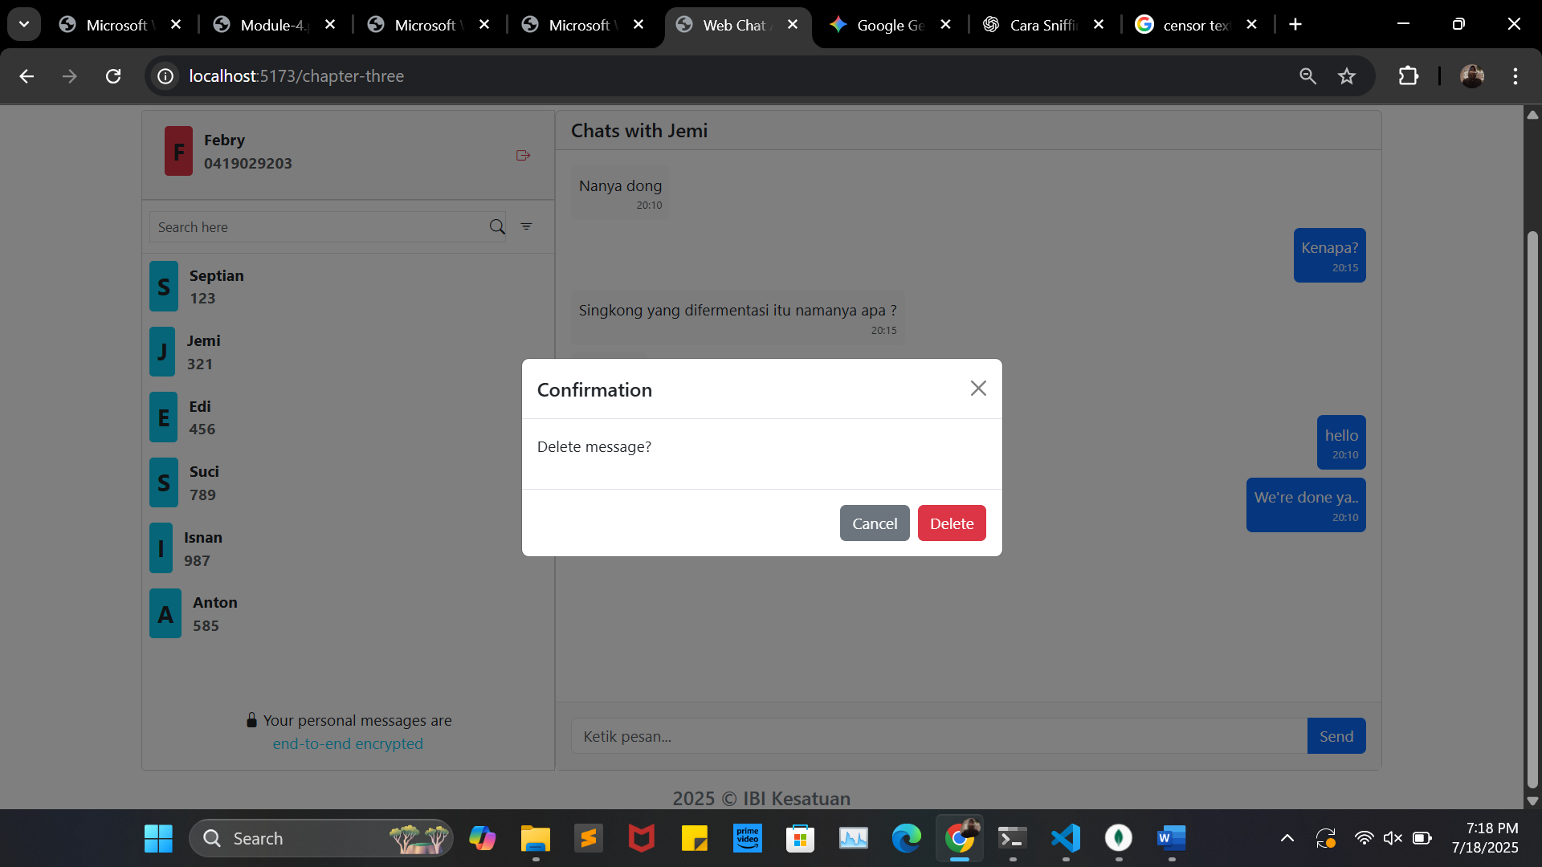

6.1-2 Sentiment berwarna dan sensor kata negatif dan ubah sentiment ke netral

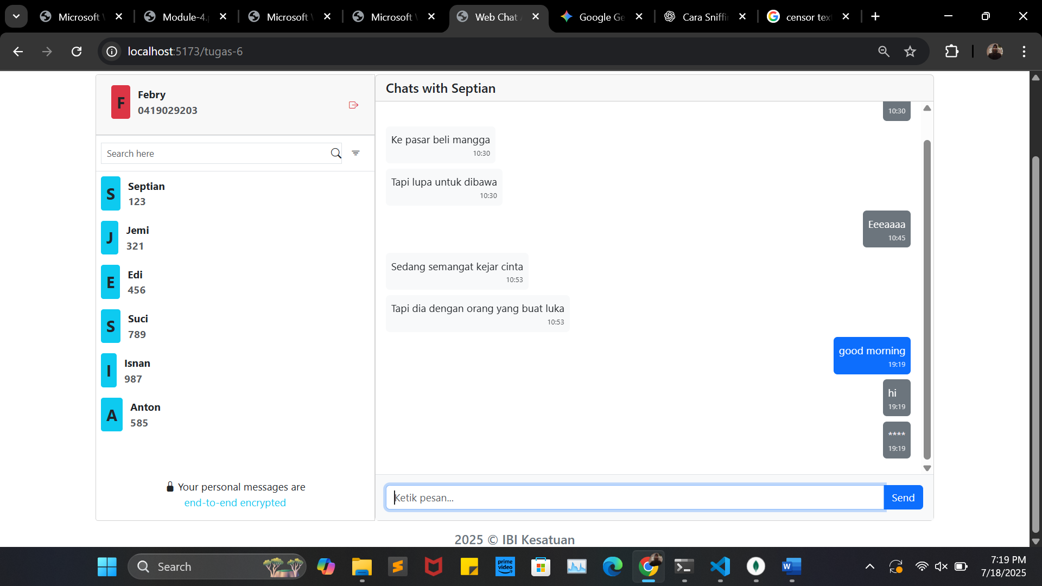

6.3 Text to speech

